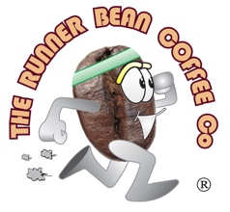
FOOD ALLERGIES

Hot Chocolate:
Malt, Milk

Cornish Pasty
Milk, Wheat, Mustard, Egg

Cheese & Onion Pasty
Milk, Wheat, Mustard, Egg

Chicken & Mushroom/Chicken Tikka,
Cheese & Ham Slice
Milk, Wheat

Steak Pie/Slice
Milk, Wheat, Barley

Cheese & Bacon Turnover
Milk, Wheat

Sausage Rolls
Wheat, Egg

www.therunnerbeancoffeeco.co.uk

